PhD Summerschool at Viðareiði Faroe Islands August 2022

Venue: Hotel Norð, Viðareiði (https://www.hotelnord.fo/) + 3 nearby houses
Schedule:
Sunday 28/8
12.25 PM Departure 28th Copenhagen Aiport (RC 453) (be there 2h before departure)
1.40 PM (local time) arrival Vágar airport
3PM bus to Gásadalur to see Múlafossur
4PM-5PM bus to Hotel Norð, Viðareiði (exchange in Klaksvík to smaller buses that fit through narrow tunnels to Viðareiði)
6PM-7.30PM Dinner
Evening program
7:30 – 8:00 Talk by Francois Renard about Faroe Islands geology, time flexible
8:00-9:00 Science/research activity 1
Monday 29th
7-8 Breakfast
9-12 Morning Program (incl. coffee break)
9:00- 9:30 Talk by Kunihiko Kaneko
9:30-10:15: 7*5 min talks (Albert Alonso, Benjamin Halager Andersen, Mohammad Reza Arastoo, Alexandra Ardaseva, Poul Marin Bendix, Lasse Bonn, Mireia Cordero)
10:15-11:00: coffee break
11:00-11:20: (1) 20 min talk by Natascha Leijnse
11:20-12:00: 6 * 5min talks (Helena Maria Davisdottir Danielsen, Amin Doostmohammadi , Andreas Eilersen, Younes Farhangibarooji, Alba García Vázquez, Miguel Garrido Zornoza)
12 Lunch
1PM-5PM (e.g. see the local old church with a guide to tell us stories followed by a short hike)
6PM Dinner
7.30PM-9PM Evening Program ( incl. coffee and cake)
7:30-7:50 (2) 20min Talk by Stanley Brown
8:00-9:00 Science/Research Activity 2, with coffee and cake
Tuesday 30/8
7-8 Breakfast
9-11AM Sailing a 2h round trip with Ferry from Hvannasund to Svínoy to Fugloy with the Ferry Ritan (https://da.wikipedia.org/wiki/M/S_Ritan)
12-1PM Lunch
1-5PM to Afternoon Program (incl. coffee/cake)
1:30-2:00 Talk by Karel Proesmans
2:00-2:45 7* 5min talks (Valeriia Grudtsyna, Liselotte Jauffred ,Mogens Høgh Jensen, Dana Taylor Kamp, Julius Kirkegaard, Irene Livia Kruse, Alessandra Lucchetti)
2:45-3:30 coffee/cake
3:30-3:50 (3) 20 min talk by Tuan Pham
3:50- 4:15 4*5min talks (Anastasios Marantos, Joachim Mathiesen, Namiko Mitarai, Guillermo Moreno Pescador)
4:15-4:30 break
4:30-5:00 Talk by Genevieve Thon
6PM Dinner
7.30PM-9PM Evening Program (incl. coffee/cake)
7:30-7:50 (4) 20 min talk by Thomas Heimburg
8:00 – 9:00 Science/Research Activity 3 with coffee and cake

Wedensday 31/8
7-8 Breakfast
9-12 Morning Program (incl. coffee/cake)
9:00-9:30 Talk by Weria Pezeshkian
9:30-10:15: 7*5 min talks (Jan Fabio Nickels, Andreas Berglund Nielsen, Malthe S N Nielsen, Pablo Purohit, Pavlina Senikoglou, Kim Sneppen, Victoria Thusgaard Ruhoff)
10:15-11:00: coffee break
11:00-11:20: (5) 20 min talk by Mathias Heltberg
11:20-11:40: 3 * 5min talks (Ala Trusina, Alexander Valentin Nielsen, Xiaochan Xu)
11:40-12:00: (6) 20 min talk by Bjarke Frost Nielsen
12 Lunch
1PM-5PM Hiking (Hiking Villingardalsfjall or Enniberg if Weather permits)
6PM Dinner
7.30PM-9PM Evening Program (incl. coffee/cake)
7:30-9:00 Science/Research activity 4 with coffee and cake

Thursday 1/9
7AM-8AM Breakfast
9AM-10AM Bus to village Gjógv
10AM-12 Local sightseeing in the Gap at the Harbor of Gjógv and a local (1h steep and safe hike) hike along the cliffside (maybe chances to see puffins)
12PM-1PM Enjoy lunch boxes prepared by the Hotel Nord
1PM Bus to Tórshavn (Hotel Føroyar, Hotel Brandan, Hilton Garden and Hotel 62N)
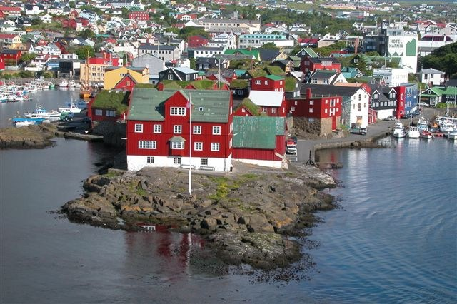
3PM-7PM Local sight seeing in Tórshavn on your own
- Old town called Tinganes contains the red ministry buildings located centrally on a nose-shaped cliff area pointing towards the harbor)
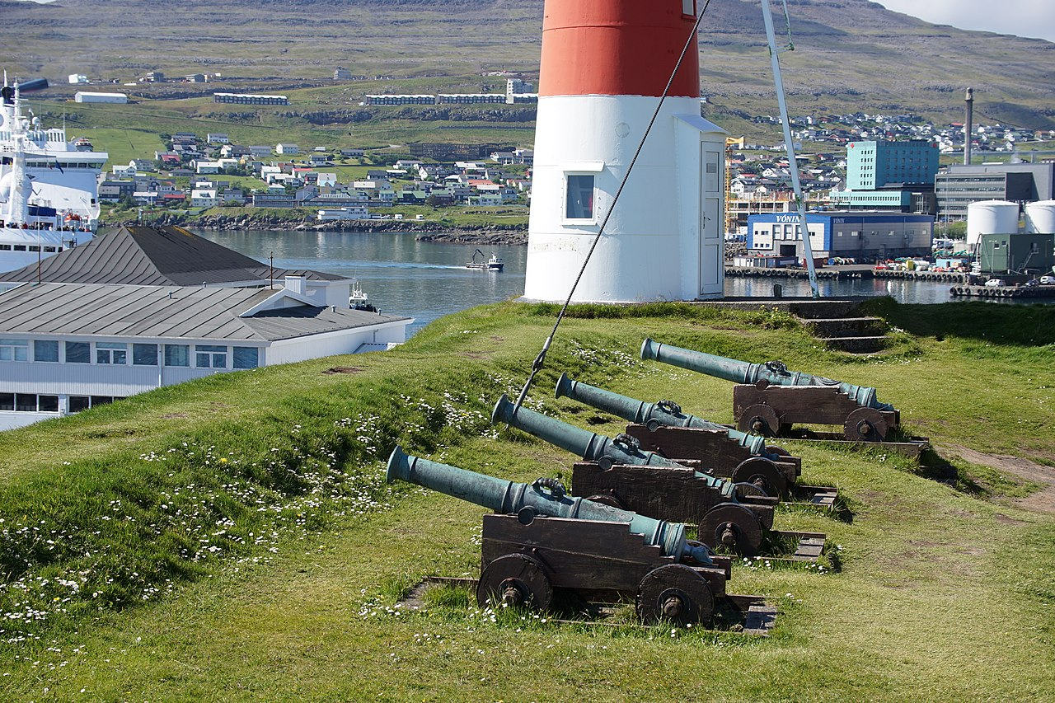
- Skansin an old fortress from 1580 used as a defense against pirates
- The walking street contains many shops with Faroese knitting products, art souviners etc..
- Tjódsavnið (Faroese National Museoum, https://www.tjodsavnid.fo/english)

8-10.45PM Dinner at Katrina Christiansen (https://en.katrina.fo/ a restaurant where the famous author William Heinesen was raised)
Enjoy the rest of the evening in Tórshavn (e.g. A beer at Mikkeller just next to the restaurant)
Friday 2/9
Breakfast at hotels
Local sightseeing in Tórshavn on your own
12.30 PM Bus from Tórshavn to airport (From 4 hotels, be prepared to wait for up to 30min)
3PM Departure from Vágar to CPH (Atlantic Airways )

