PRINCIPLES OF NEUTRON REFLECTIVITY

The Schrödinger equation for an elastically scattered neutron may be written as:
ψ(r) is the neutron wave function, E and m its energy and mass respectively, V(r) a potential that describes the interaction of the neutron with its surrounding media.

The neutron wave is a plane wave in the z-direction, and has infinite span in the xy-plane. As a result V(r) may be averaged over all atoms in the assembly to give:
The potential is only nonzero when R = r_{j}, because the nuclei are much smaller (10⁻¹⁵ m) than thermal neutron wavelengths (10⁻¹⁰ m) and scatter like point objects.

The average coherent scattering length density ρ of a material is related to its composition (b_{j} is the coherent nuclear scattering length and n_{j} number density):
from which it follows that the average interaction potential may be written as:
Table.1. Neutron scattering lengths of common elements[1]. Unless an isotope is specified, the value of b has been calculated according to natural abundance.
Nucleus | b/ 10⁻⁵ Å⁻¹ | atomic weight
¹H | -3.7406 | 1.0078
²H | 6.671 | 2.008
C | 6.646 | 12.01
N | 9.36 | 14.01
¹⁶O | 5.803 | 15.997
Na | 3.63 | 22.99
²⁹Si | 4.1491 | 28.068
³¹P | 5.13 | 30.974
S | 2.874 | 32.066
Cl | 9.577 | 35.453
Ca | 4.7 | 40.078

Reflection from a planar interface

The possible fates of a neutron striking a planar interface between two media of different refractive indices are shown in Fig. 1. These are specular (SR) and off-specular (OSR) reflection, refraction i.e. transmission (T) and in-coherent scattering (ICR).
Fig. 1. Neutron scattering events at an interface.
k_{i}
k_{icr}
k_{sr}
k_{osr}
k_{t}
θ
θ
n₁
n₂
z
y
x

The two media having different neutron refractive indices means that they are characterised by two different interaction potentials V₁ and V₂. If the two media are homogenous over the xy-plane, the only change in the neutron wave upon reflection or refraction can occur in the z-direction. The neutron motion is described by a complex plane wave:
where the wave vector k_{x} describes the propagation of the wave parallel to the reflecting interface (does not change in elastic scattering). Substitution of into the Schrödinger equation gives:
where q is known as the momentum transfer vector given by:
However, the incident wave will be partially reflected and partially transmitted:
These equations contain the r and t reflection and transmission coefficients, which may be determined from q₁ and q₂ by considering the boundary conditions of the situation. At the interface, both ψ(z) and ∇ψ must be continuous, therefore , at z = 0 becomes:
and the derivatives ∇ψ
Solving and simultaneously gives:
and
These two coefficients are the Fresnel coefficients for reflection and transmission at a planar interface between two uniform media, and the reflectivity has been shown to be

Reflectivity and scattering length density
Fig. 2. Geometry of reflection and transmission; relation of wave vectors.
k_{i}
k₁
k₂
θ₁
θ₁
n₁
n₂
z
y
x
θ₂
q₁ = k₁sinθ
q₂ = k₂sinθ
k_{x} = k₁cosθ₁ = k₂cosθ₂

In order to relate reflectivity to chemical composition at an interface, it is desirable to express the Fresnel coefficients in terms of the scattering length density or the neutron refractive index.

The relations between reflection and transmission wave vectors k₁ and k₂ and the momentum transfer vectors q₁ and q₂ are illustrated in Fig. 2 where θ_{i} is the angle measured to the surface. Since the in-plane components in the specular, elastic case must be equal,
the momentum transfer vectors are
and
with
It then follows from equation that
By analogy to light refraction, the neutron refractive index between two media is simply the ratio of wave vectors:
Combining equations with leads to Snell’s Law:

and using equation
The neutron energy E is given by the de Broglie relation (E = h²/2mλ²) for a given neutron wavelength, and the potentials can be expressed in terms of the scattering length densities of the two media V_{i} = h²ρ_{i}/2πm (equation ), leading to:
which simplifies to first order to:
Total reflection occurs when θ₂ = 0, and Snell’s Law allows us to define a critical angle θ_{c} as
Experimentally, the total momentum transfer in the z-direction, 2ksinθ, is measured, which also has a critical value according to the compositions of the two media involved:
E.g. in the case of the silicon-D₂O interface, the critical momentum transfer Q_{c} has a value of 0.0147 Å⁻¹.

Reflection from an adsorbed layer

The model for reflection between two media expressed in terms of refractive indices can be extended to include a thin film adsorbed at the interface.
Fig. 3. Reflection from an adsorbed film.
k_{i}
k₂
θ₀
k₁
θ₀
θ₂
ρ₀

ρ₂
ρ₁

θ₁
k₁
θ₀

Reflection and transmission are still given by the Fresnel coefficients r_{ij} and t_{ij} at each interface[2], and the total reflected amplitude is given by the series:
where β is the phase difference of a wave that has travelled through a layer with thickness τ:
Using the conservation of energy, and noting that r₁₂= -r₂₁
the reflected amplitude R becomes:

The reflectivity is then given by the square of the modulus of the amplitude:
The maxima and minima in R will occur at values of cos2β = ± 1, allowing the estimation of layer thickness from their positions by:

The optical matrix method

The Fresnel reflection coefficients can be calculated for more complicated systems using the general optical matrix method by Born and Wolf[2]. Adsorbed layers are approximated as smooth, homogeneus slabs of materials each with a characteristic scattering length density.
Fig. 4. Model for reflection from a layered material used in optical matrix calculations. Note that ρ₀ > ρ₁, ρ₁ < ρ₂, ρ₂ > ρ₃ and ρ₃ < ρ₄.
ρ₀
ρ₁
ρ₂
ρ₃
ρ₄
θ₀
θ₁
θ₂
θ₃
r₀₁
r₁₂
r₂₃
r₃₄
t₀₁
t₁₂
t₂₃

t₃₄

For each layer, a characteristic matrix can be defined, describing the reflection and transmision of neutrons:
and the total reflectivity amplitude matrix is the product of all the layers:
The reflected amplitude is given by:
and the reflectivity R, by the squared modulus of this.

Interfacial roughness can be included in the optical matrix by modelling it as a Debye-Waller type smearing out of the interface location:
where σ is the mean interfacial roughness and R is the reflected intensity in the absence of roughness. An alternative optical matrix was defined by Abeles[3], into which this factor is already incorporated:
where r⁺_{j} are the modified reflection coefficients:
and the reflectivity is given by:
$R_{j}=\frac{m_{\text{12}}m_{\text{21}}}{m_{\text{11}}m_{\text{22}}}={\left|r_{j^{+}}\right|}^{2}$
where m_{ij}* is the complex conjugate of m_{ij}.

Contrast variation

For a layered model such as in Fig. 4, it is always possible to calculate the exact reflectivity using an optical matrix model, but solving a reflectivity profile is not as straightforward, as there is usually more than one possible model. This is because neutron reflection (which measures only the intensity of reflection) suffers from the phase problem like all scattering methods.

Fig. 5 shows four scattering length density profiles which would give rise to the same reflectivity within the kinematic approximation of reflection[4]. In practise it is usually possible to distinguish between the a/b and c/d pairs from knowledge of the properties of the bulk media involved, but determining which of each pair is in question is problematic for very thin films (τ ≤50Å), when the experimentally accessible q-range does not allow the observation of interference fringes. The most common way around this problem is to use several chemically identical systems with different scattering length density profiles, known as contrast variation.

In biological studies, the large water content of the materials gives access to a number of chemically similar systems by varying the H/D content of the water, or by isotopic substitution of the biomolecules themselves. By measuring reflectivity from a number of such contrasts, a unique solution to the structure is usually found from simultaneous fitting aided by basic chemical knowledge of the materials involved.
a)  (ρ₂-ρ₁)  ρ(z)  z  ρ₀  ρ₁  ρ₂  (ρ₁-ρ₀) | b)  ρ(z)  ρ₀  ρ₁  ρ₂  z
c)  ρ(z)  ρ₀  ρ₁  ρ₂  z | d)  ρ(z)  ρ₀  ρ₁  ρ₂  z
Fig. 5. Scattering length density profiles that give rise to the same kinematic reflectivity. a) and b) are related by interchanging the values of (ρ₂-ρ₁) and (ρ₁-ρ₀), and that the a/b pair is related to c/d by an inversion of the signs of (ρ₂-ρ₁) and (ρ₁-ρ₀) with respect to ρ₀.
The scattering length densities of membrane lipids can be calculated for example from volume elements obtained from molecular dynamics simulations[5, 6], which have been shown to be in good agreement with experimental data from density[7] and X-ray/neutron diffraction measurements[8]. Tables 3-5 give a summary of scattering lengths, volumes and scattering length densities used in data analysis.
Table 3. Phospholipid component volumes from molecular dynamics simulations [6].
Group | V (DPPC)/ Å³ | V (DOPC)/ Å³ | V (POPC)/ Å³
CH₃ | 53.57±0.91 | 52.79±0.4 | 50.41±0.77
CH₂ | 27.93±0.1 | 28.13±0.09 | 28.24±0.17
C=C |  | 45.91±0.69 | 42.1±2.31
COO Carbonyl | 43.58±1.05 | 37.4±1.28 | 38.43±1.47
C₃H₅ Glycerol backbone | 65.47±2.11 | 81.62±2.96 | 72.48±2.28
PO₄ Phosphate | 66.36±2.95 | 51.05±6.31 | 52.12±2.23
C₅H₁₃N Choline | 107.62±2.49 | 129.68±5.25 | 120.68±2.98
H₂O | 29.5±0.5 | 29.5±0.5 | 29.5±0.5
Total | 1215.79±14.27 | 1322.19±20.52 | 1255.78±17.12
Experimental [7-10] | 1232 | 1295 | 1267
Table 4. Scattering length densities of phospholipids
 | h-DPPC | d₆₂- DPPC | DOPC | POPC
b_{headgroup}/ 10⁻⁵ Å⁻¹ | 60.0432 | 60.043 | 60.0432 | 60.0432
V_{headgroupg}/ Å³ | 326.25 | 326.25 | 337.15 | 322.14
ρ_{headgroupg}/ 10⁻⁶ Å⁻² | 1.840 | 1.840 | 1.781 | 1.864
b_{chains}/ 10⁻⁵ Å⁻¹ | -32.5372 | 612.98 | -20.916 | -26.726
V_{chains}/ Å³ | 889.18 | 889.18 | 985.04 | 933.68
ρ_{chains}/ 10⁻⁶ Å⁻² | -0.3659 | 6.894 | -0.2123 | -0.286

The values of protein scattering lengths can be calculated from the protein sequence assuming that all labile hydrogens[11] of the residues will exchange with the solvent. If the crystal structure of a protein is not known, its molecular volume can be estimated from the sum of the solution volumes of amino acid residues[12].
Table. 5. Amino acid scattering length densities[11, 12].

Code | Residue | Exchangeable H | b/ 10⁻⁴ Å⁻¹ | mass/g mol⁻¹ | Volume/ Å³
A | Alanine | 1 | 1.645 | 71.09 | 88.6
R | Arginine | 6 | 3.466 | 156.19 | 173.4
N | Asparagine | 3 | 3.456 | 115.09 | 114.1
C | Cysteine | 2 | 2.88 | 103.15 | 108.5
SS-CYS | SS-Cysteine | 1 | 3.254 | 102.14 | 108.5
D | Aspartate | 1 | 3.845 | 114.11 | 111.1
E | Glutamic acid | 1 | 3.762 | 129.12 | 138.4
Q | Glutamine | 3 | 3.373 | 128.14 | 148.3
G | Glycine | 1 | 1.728 | 57.05 | 60.1
H | Histidine | 1.5 | 4.959 | 137.14 | 153.2
I | Isoleucine | 1 | 1.396 | 113.16 | 166.7
L | Leucine | 1 | 1.396 | 113.16 | 166.7
K | Lysine | 4 | 1.586 | 128.17 | 168.6
M | Methionine | 1 | 1.764 | 131.19 | 162.9
F | Phenylalanine | 1 | 4.139 | 147.18 | 189.9
P | Proline | 0 | 2.227 | 97.12 | 112.7
S | Serine | 2 | 2.225 | 87.08 | 89
T | Threonine | 2 | 2.142 | 101.11 | 116.1
W | Tryptophan | 2 | 6.035 | 186.12 | 227.8
Y | Tyrosine | 2 | 4.719 | 163.18 | 193.6
V | Valine | 1 | 1.479 | 99.14 | 140

Experiment

The purpose of a neutron reflection experiment is to measure the intensity of specular reflection as a function of momentum transfer q_{z} perpendicular to the surface. This is possible in two ways. With a monochromatic neutron beam both reflection (θ) and detector (2θ) angles are varied to scan the entire q-range. Time-of-flight (TOF) reflection experiments operate at fixed values of θ, and a range of momentum transfer values corresponding to the wavelengths in a polychromatic neutron beam are recorded simultaneously.

The resolution in reflection experiments is determined by both the angular (Δθ) and wavelength (Δλ) spread:

In the TOF mode, the neutron wavelengths are determined by recording the arrival time of each neutron at the detector relative to the start of each pulse, with shorter wavelengths arriving first and corresponding to high values of q. On steady state reactor beams, a pair of mechanical choppers is used to define a pulse of neutrons, with separation and length of individual pulses determined by the chopper speed and relative phase. TOF measurements are suitable for kinetic measurements, i.e. recording reflectivity profiles R(q) from an interface whose structure changes with time. It is possible to capture unique sets of R(q) as “snapshots” of the time evolution of such interfaces provided that the timescale of the process is of the same order as the neutron counting time, with a typical example being macromolecular adsorption.

The reflected neutrons can be detected in two ways, either by a single detector set to capture only the specular beam, or by a position sensitive area detector, that records both the specular and non-specular (containing q_{x} and q_{y} components) reflections. The addition the ability to observe off-specular reflection often gives useful information on interface morphology in terms of substrate quality and/or the state of aggregation in an adsorbed film.
Figure 7. Scattering geometry of a typical reflectometer with area detector
Detector
2θ
Si
θ
Δx= y tan (2θ)
DET ~ 3m
R
T
Because the multi-detector is position sensitive, a position x on the screen is related to the detector angle (2θ) and the angle of incidence (θ) and the sample-to detector distance DET which allows one to determine the sample angle from the location of the specular beam: (see Fig. 7.):

This relation is a convenient way to calibrate the incident angle from knowledge of the specular beam position Δx.

Measurement of reflectivity and data analysis

In a reflectivity experiment a transmission beam spectrum is recorded for each of the incident angles and slit settings to calibrate the reflected intensity onto an absolute scale. This is what allows absolute composition of films to be determined.

Before analysing the reflectivity data it is also necessary to correct for the incoherent background scattering and to often combine 2 or more reflectivities recorded at different incident angles. The process is elucidated by an example below.

a)  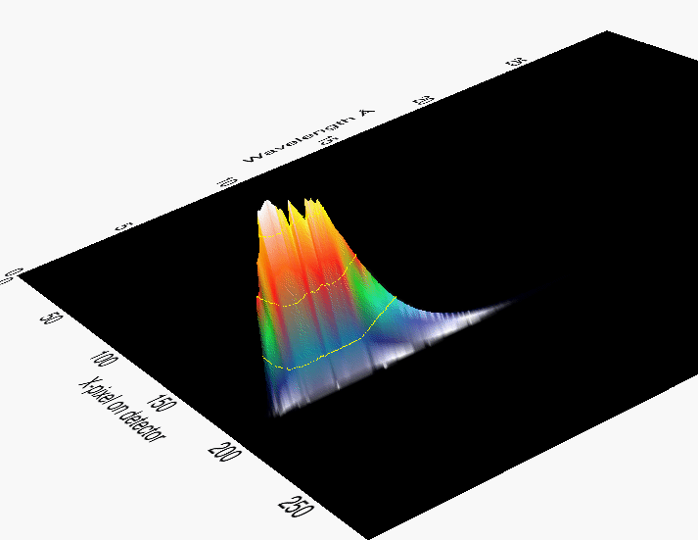 | b)  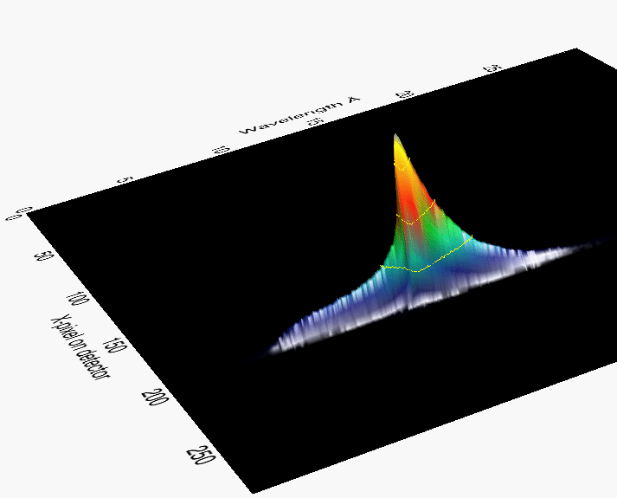

c)
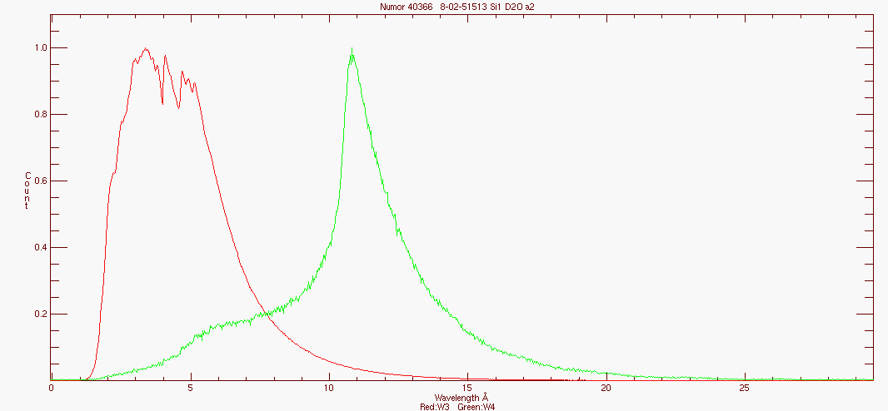
Figure 8. Raw detector images in time-of-flight of a) the incident beam and b) of the reflected beam. c) Neutron spectra (summed over the detector y-pixels) of the incident beam (red) and reflected beam (green) at a silicon-D2O interface. Angle of incidence 0.7°. (the reflectivity has been scaled in intensity for this plot – the true intensity is only ~ 10% of the incident beam).

Reflectivity results are always displayed as the relative intensity I/I₀ vs the scattering vector q. To do this, the reflected neutron spectrum (see Fig. 8) has to be divided by the incident neutron spectrum. The result in wavelength is shown in Figure 9.

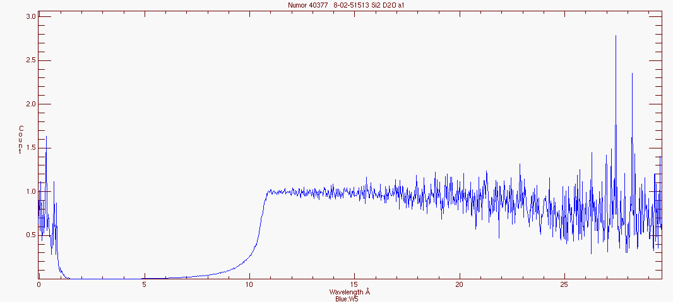

Figure 9. The raw reflectivity profile of a silicon-D2O interface plotted as I/I₀ vs wavelength. I/I₀ = 1 below the critical wavelength (in this case ~ 10.6 Å).

The data is then transformed in to Reflectivity (I/I₀) vs Q (= 4πsinθ/λ), which is usually presented on a logarithmic scale:
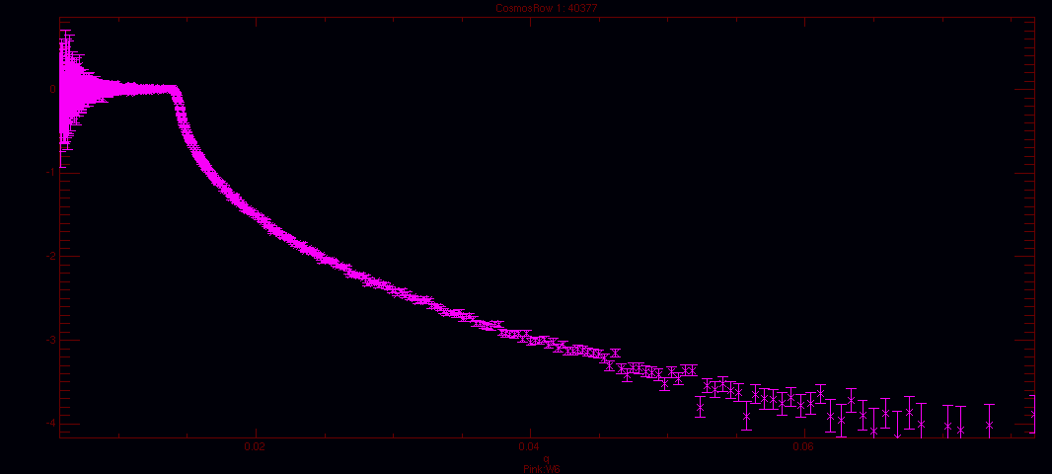

Figure 10. Logarithmic reflectivity profile of a silicon-D2O interface recorded at an angle of 0.7°

The logarithmic reflectivity is always zero when total reflection occurs below the critical edge, e.g. q = 0.0147 Å for the silicon-D2O example.

Reflectivity profiles recorded at higher incident angles can then be combined to low-angle profile, provided there is sufficient overlap in the q-ranges. Background subtraction is performed by removing background scattering separately for each point along the specular ridge, assuming that all non-specular reflectivity is The background arises from the incoherent scattering from the aqueous sample, and is generally found to be ~ 1 x 10⁻⁶ for D₂O and ~ 3 x 10 ^{–6} for water contrast matched to silicon (sld = 2.07).

The most common way to analyse reflectivity data is to compare measured profiles with simulated profiles generated by an optical matrix calculation. Several programs exist and are available to neutron users as freeware, for example the Motofit[13] program allows modelling of the film structure as a series of layers with variable scattering length density, thickness, roughness and solvent content.

When a layer is composed of two components, a chemical species and water, the scattering length density is given by:
where ρ_{s}/ρ_{w} are the scattering length densities of species s and water, respectively and φ is the volume fraction of species s in the layer. If more than one chemical species is present, then ρ_{s} is determined by the volume fraction of each species in the layer. In practise, programs like Motofit allow fitting of ρ_{s} and φ_{s} as separate variables. Equation can be written as:
with Σ_{i} b_{i} corresponding to neutron scattering lengths of the nuclei. If A is the area per molecule then the volume per molecule a + its associated water is given by:
From this follows that:
and therefore
It is more common to refer to the a value of surface excess Γ (μmol m⁻²), obtained from
if A is given in Å².

DATA ANALYSIS OF MODEL BIOLOGICAL MEMBRANES

Data analysis of mode lipid membranes is often done in terms of layered models of the membrane, which is divided into the hydrophobic lipid chains and the hydrophilic headgroups. Usually several water contrasts are used to determine the membrane composition, which is demonstrated in Figure 10.

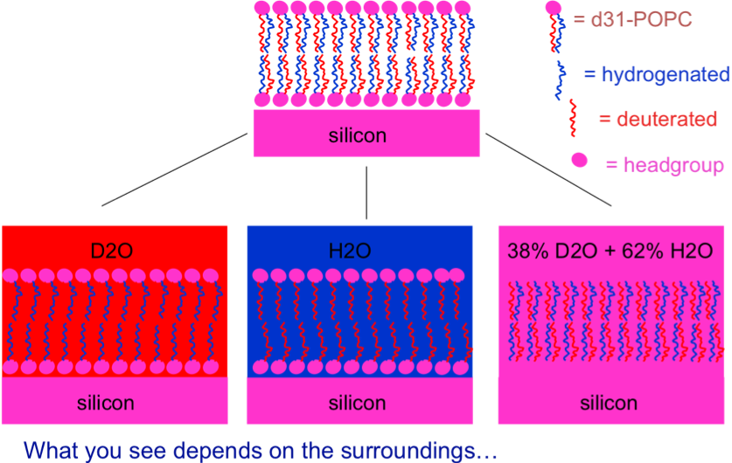

Figure 11.The principle of water contrast matching – the parts of the films which have the same scattering length density as the water appear invisible and can be determined one by one by changing the water.

For lipid bilayers, the most often quoted structural parameters are the hydrophobic and headgroup thicknesses, the area per molecule and surface coverage = number of molecules per unit area. In fitting reflectivity data it is necessary to ensure that the membrane models are realistic by applying a stoichiometric rule of space filling – the membrane should have the same total surface area on both sides, and the number of headgroups in each leaflet should be ½ the number of chains. This ensures that the hydration of the headgroups is correctly modelled with respect to the area occupied by the lipid chains. An example of the calculation of lipid structural parameters is given below.

E.g. d54-Dimyristoyl phosphatidylcholine: C₃₆H₁₈D₅₄NO₈P – MW 732.265

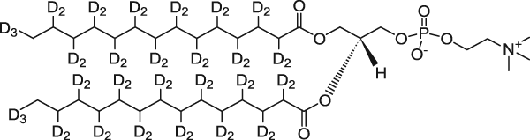

water | layer | V_{m}/ Å₃ | ρ /Å⁻² | ρ_{a} Å⁻² | t/ Å | φ | V_{a}/ Å³ | A_{a}/ Å² | n_{w} | Γ/ μmol m⁻²
 | head | 326 | 1.8 | 2.6 | 6 | 0.83 | 394 | 66 | 2.2 | 5.06
D2O | chains | 1555 | 6.8 | 6.7 | 28 | 0.85 | 1829 | 65 | 4.6 | 5.08
 | head | 326 | 1.8 | 2.6 | 6 | 0.83 | 394 | 66 | 2.2 | 5.06
 | head | 326 | 1.8 | 1.4 | 6 | 0.83 | 394 | 66 | 2.2 | 5.06
H2O | chains | 1555 | 6.8 | 5.7 | 28 | 0.85 | 1829 | 65 | 4.6 | 5.08
 | head | 326 | 1.8 | 1.4 | 6 | 0.83 | 394 | 66 | 2.2 | 5.06

Table 6. Fitted variables (t and ρ) and the membrane structural parameters calculate from them for a chain deuterated d₅₄-DMPC bilayer.

V_{m} is the volume per molecule (in this case divided into the chains and heads)
ρ is the molecular scattering length density sum of b_{i} over V_{m}
φ is the volume fraction of the lipid in the layer = 1- solvent fraction
ρ_{a} is the scattering length density of the layer including the solvent
t is the layer thickness
V_{a}=V_{m}/ φ is the volume occupied by each molecule (or tails/heads) + the solvent
A_{a} = V_{a}/t is the area occupied by the molecule and solvent
n_{w} = (V_{a}-V_{m})/V_{w} is the number of waters per molecule V_{w}= molecular volume of water
Γ = N_{A}/A_{a} expressed as micromoles per cm² typically

References

