**Getting started with iMosflm and Scala**

Leila Lo Leggio 2011 (modified by Osman Mirza 2012)

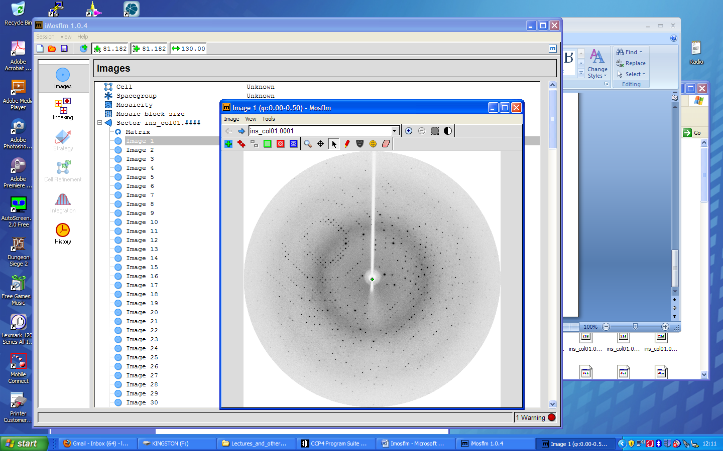**Data indexing and integration (Mosflm)**

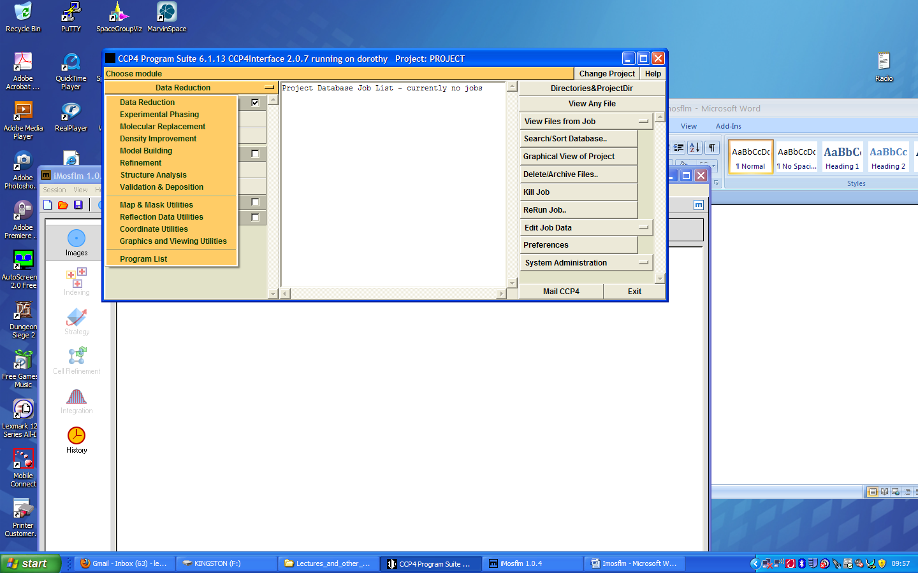Start CCP4i and choose ‘**Data Reduction**’ from the yellow menu.

Now tick on the white box next to ‘**Data processing using Mosflm’** and then **‘Start iMosflm**’

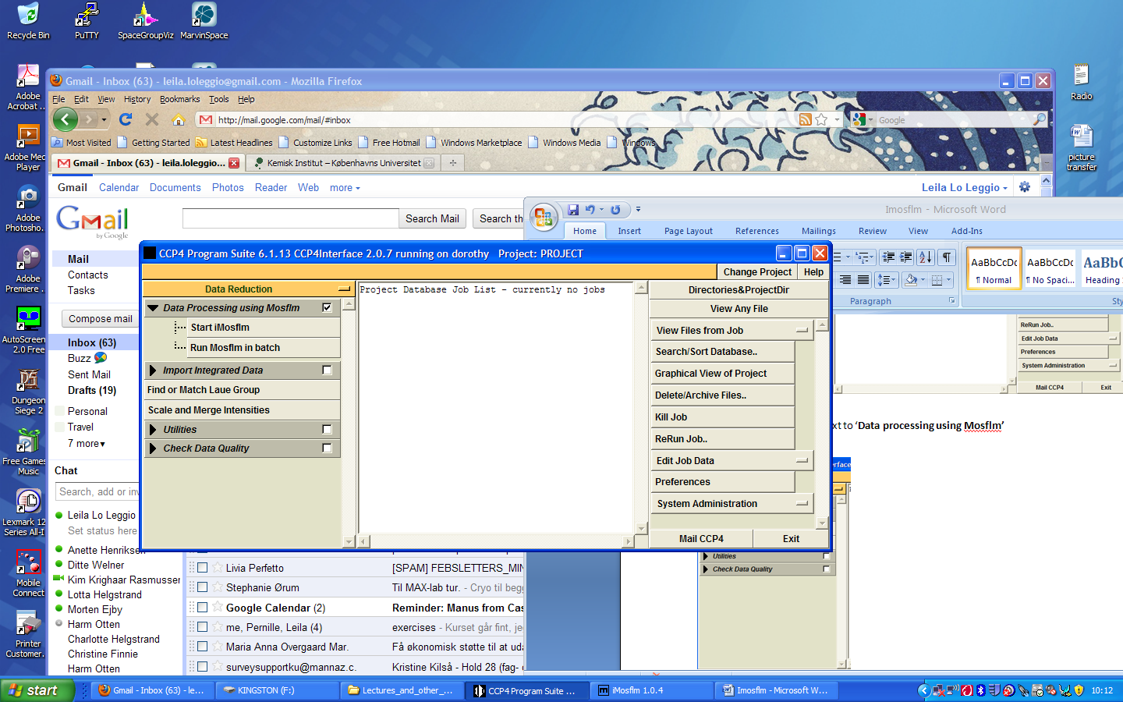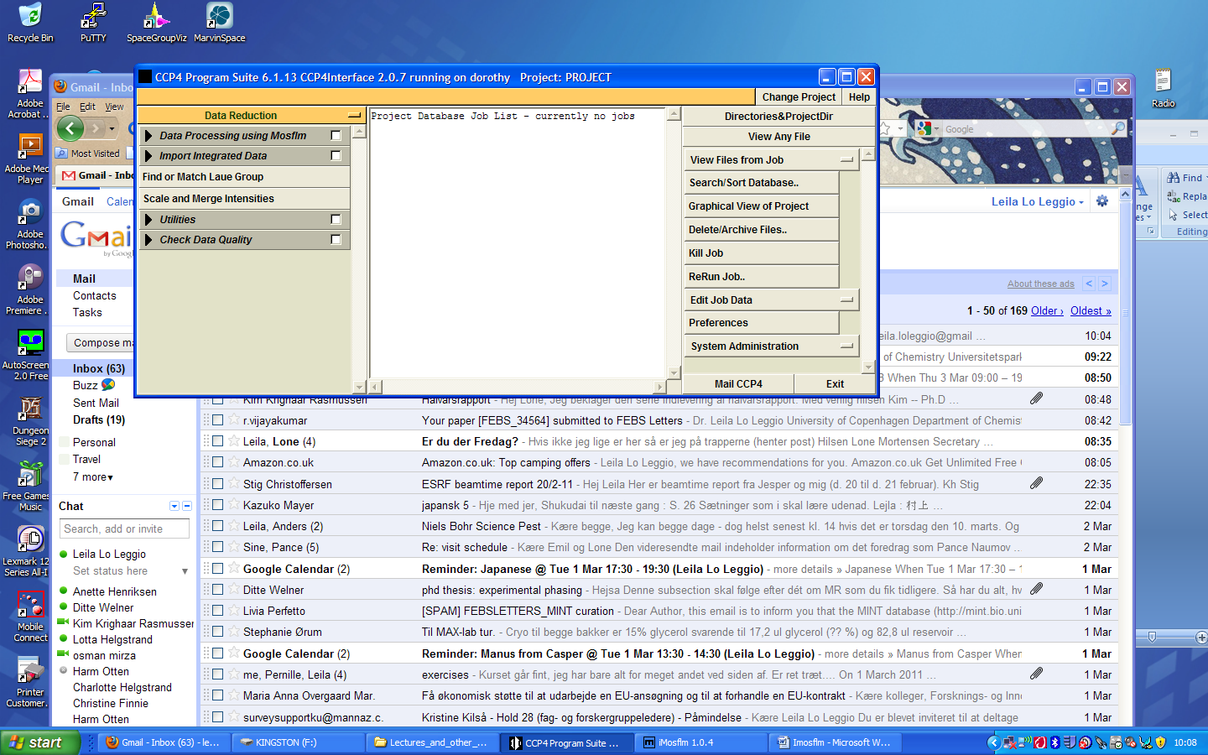

Now the iMosflm GUI should come up.

Click on the indicated icon on the top bar to load images. TIP If you cannot see any images in the folder where you KNOW they must be, it is probably because the wrong file type is selected.

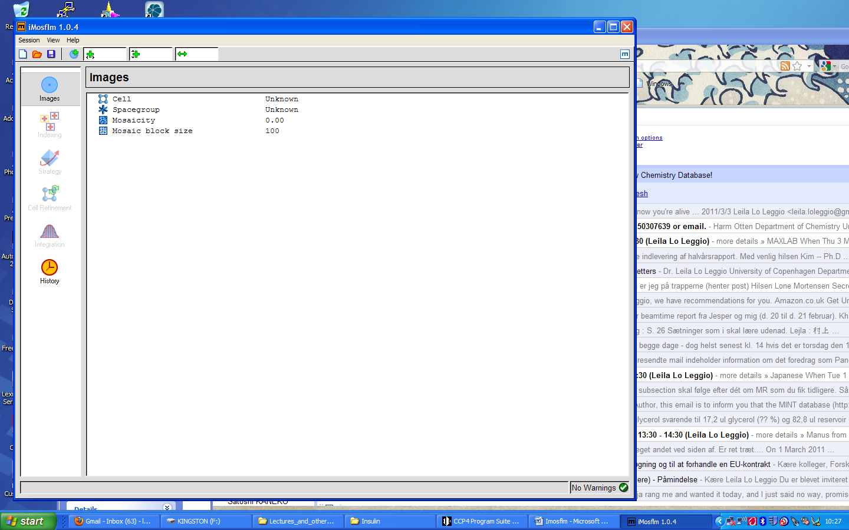

Now your images are read.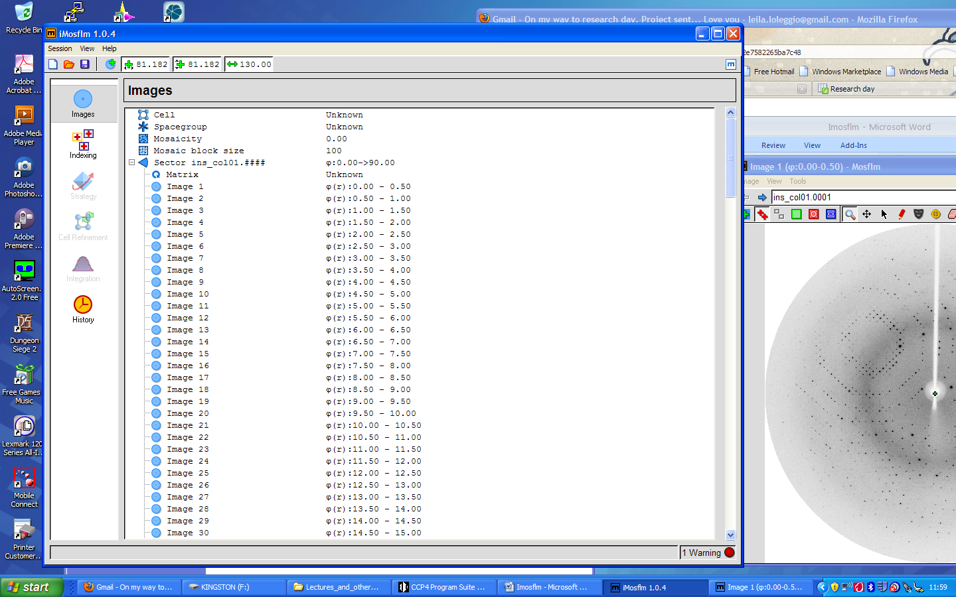

The image viewer will now appear. Familiarize with the different options in the toolbar.

In particular make sure that the area masking the beamstop is appropriate, by viewing it (icon shown by the arrow. If not correct it by first clicking on the arrow icon and then moving the masking area with the mouse.





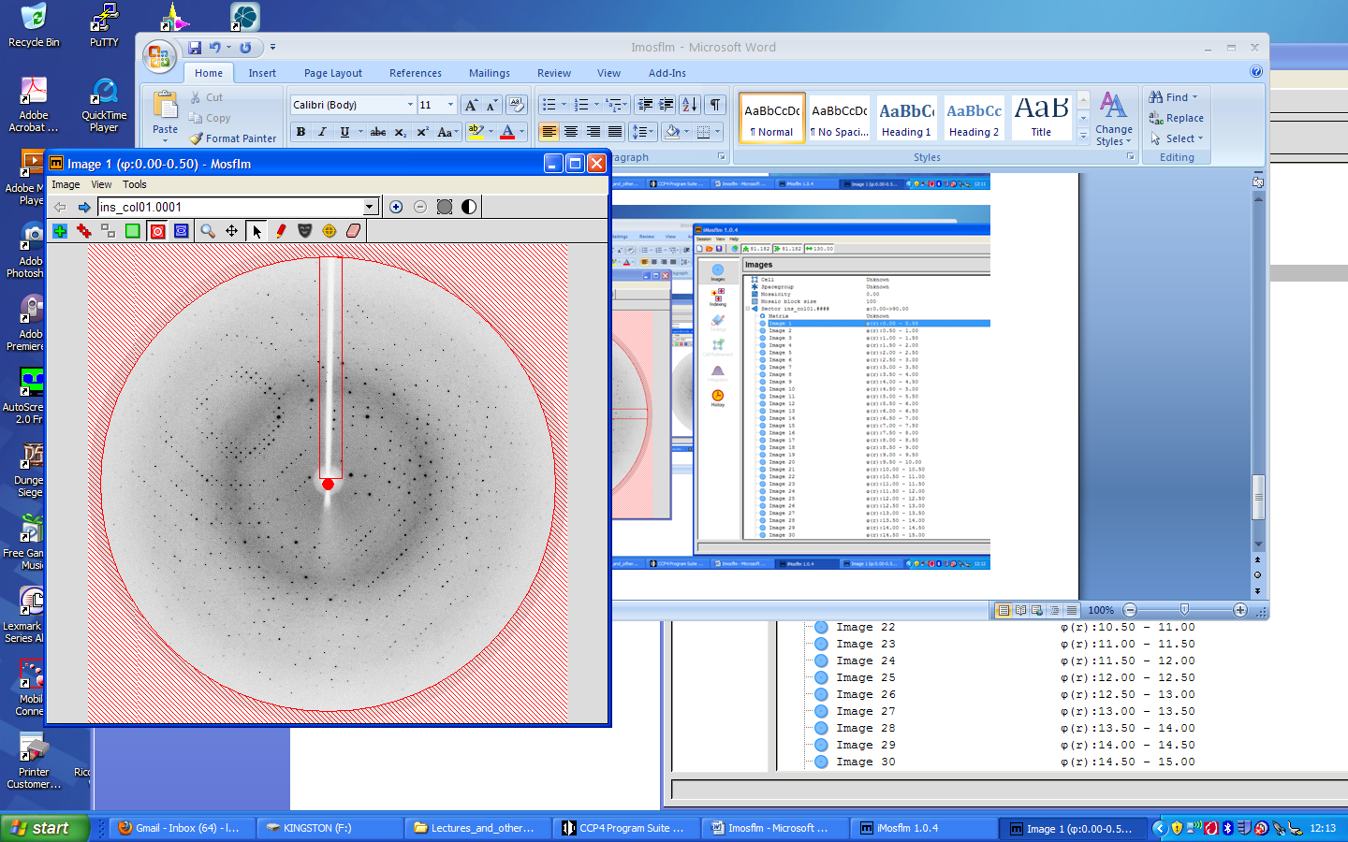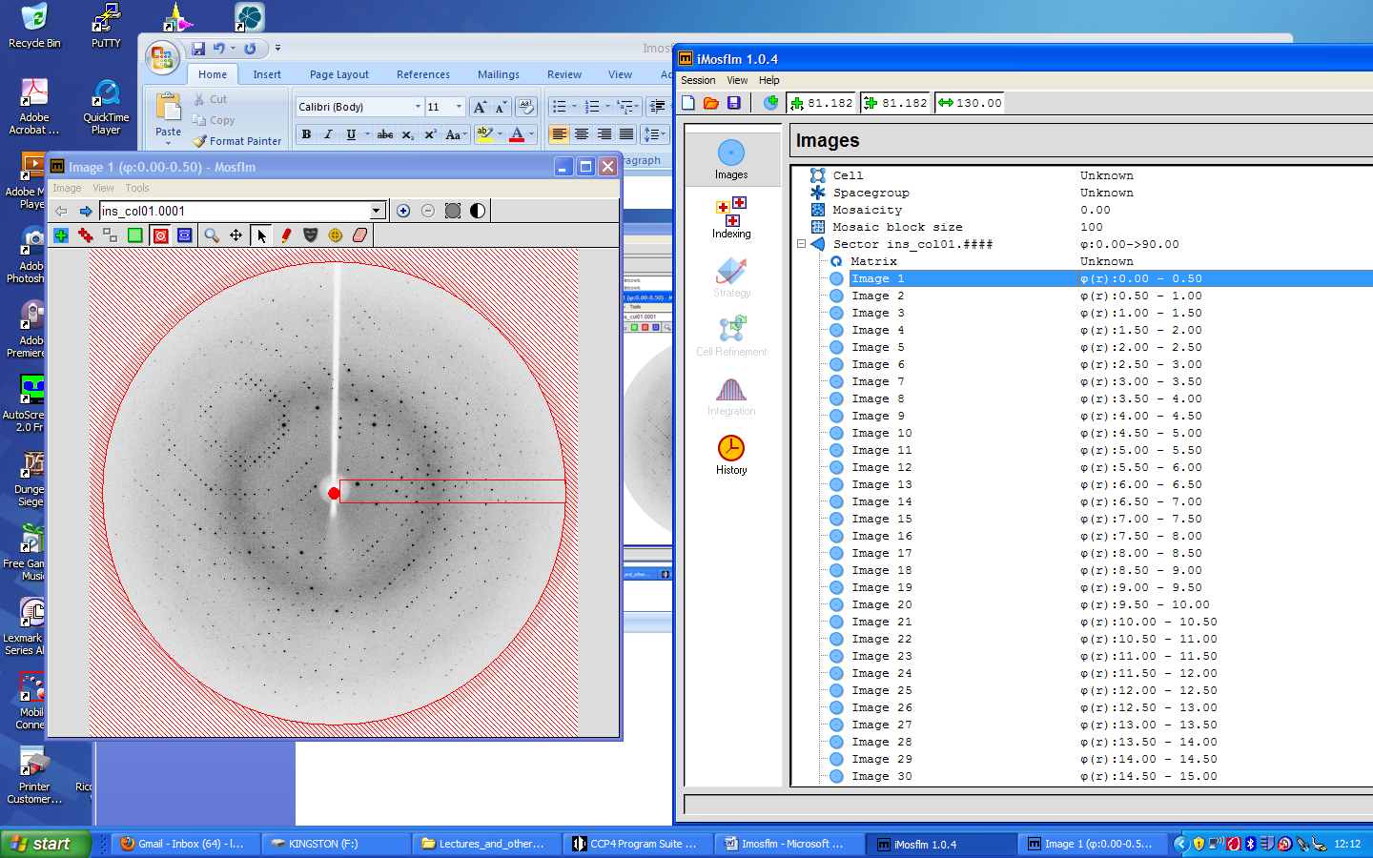

Now you are ready to index! So just click on Indexing on the side bar, and things will start happening.

On the main window, things will look something like this (an example from a different crystal):

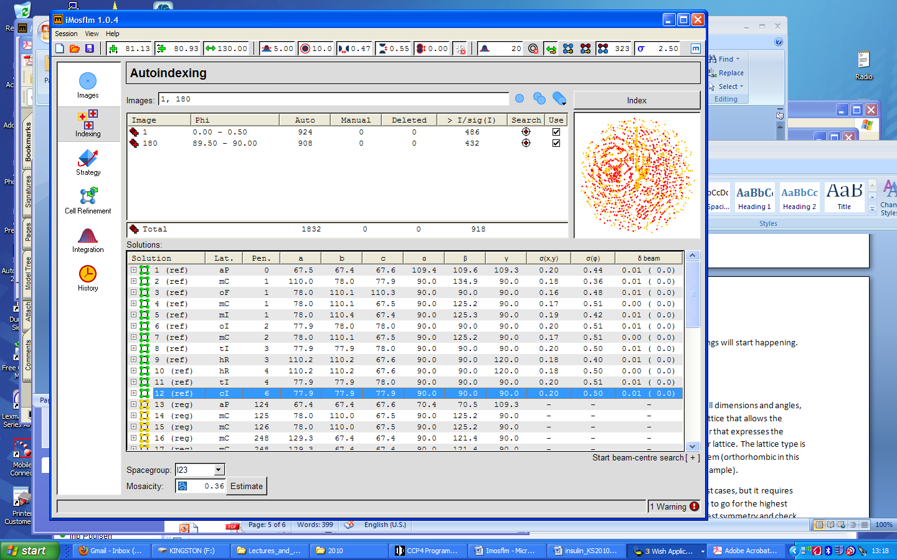





For each plausible solution found by the program, the penalty, lattice type, cell dimensions and angles, and possible space groups are listed by the program. We want to select the lattice that allows the highest possible symmetry, but still has a low penalty. The penalty is a number that expresses the distortion from ideal geometry necessary to fit the real spots to that particular lattice. The lattice type is expressed as, for example oF, where the small letter indicates the crystal system (orthorhombic for oF) and the capital letter indicates centering, if any (face-centered in this example).

The program usually suggests a solution, and this is reasonable in most cases, but you can choose another solution by clicking on it (however, think very carefully before choosing one of the yellow solutions, as the right one is almost for sure among the green ones!). A very important parameter in your choice is whether the predicted spot positions coincide at least approximately with real spots, check this in the image viewer (best dome by zooming). If you see no predictions click them on. If you click on another solutions, the predictions change too.

You should also consider which space group you should choose among the possible ones in the spacegroup box. A good strategy is to choose the highest symmetry first and see if the data reduction statistics are sensible. Alternatively on could choose the lowest symmetry and check visually for additional symmetry elements later (but then you have to be good at identifying symmetry). As a first choice it is a good idea to choose space groups without screw axes, and check later for the presence of systematic absences.

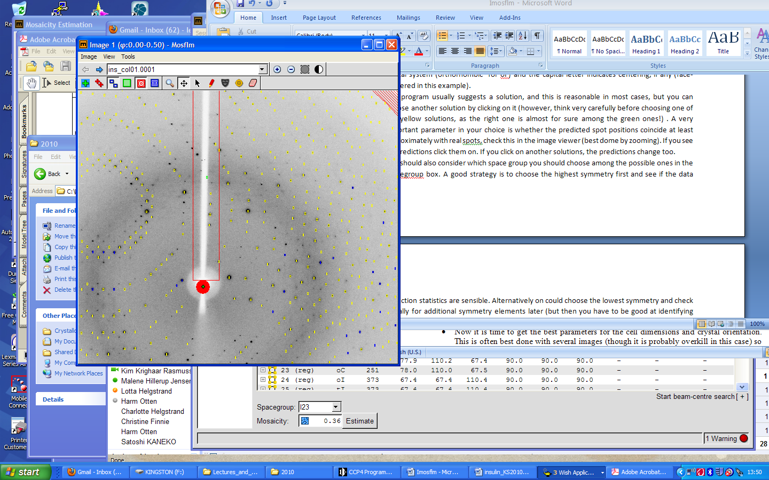



Fully recorded reflection

Partially recorded reflection

Overlapped reflection (excluded)

Reflection width too large (excluded)

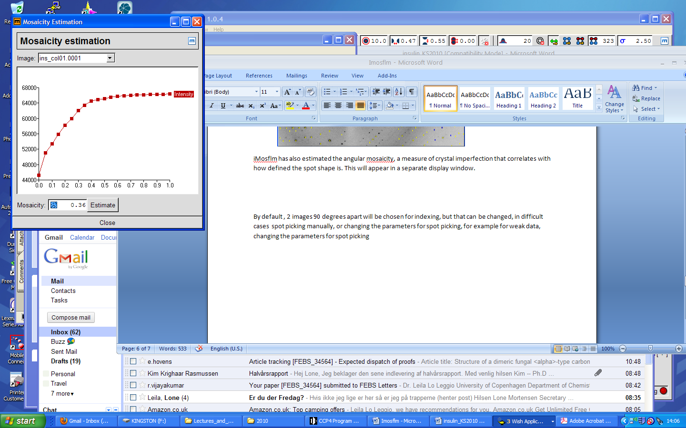iMosflm has also estimated the angular mosaicity, a measure of crystal imperfection that correlates with how defined the spot shape is. This will appear in a separate display window.

By default , 2 images 90 degrees apart will be chosen for indexing, but that can be changed, as can be the parameters for spot picking, if data is weak (arrows below).

When the indexing looks appropriate, then the cell needs to be refined, which can be done by clicking the appropriate button on the side bar. Normally, refinement is against 8-10 frames at about 90⁰ from each others, but this can be changed in difficult cases. There are also other options that can be used with very low resolution or troublesome datasets, such as excluding refinement in ice rings regions, or fixing some parameters. Check that the predicted spots are still right after cell refinement! The spot profile shown is the average for the central region of the detector.







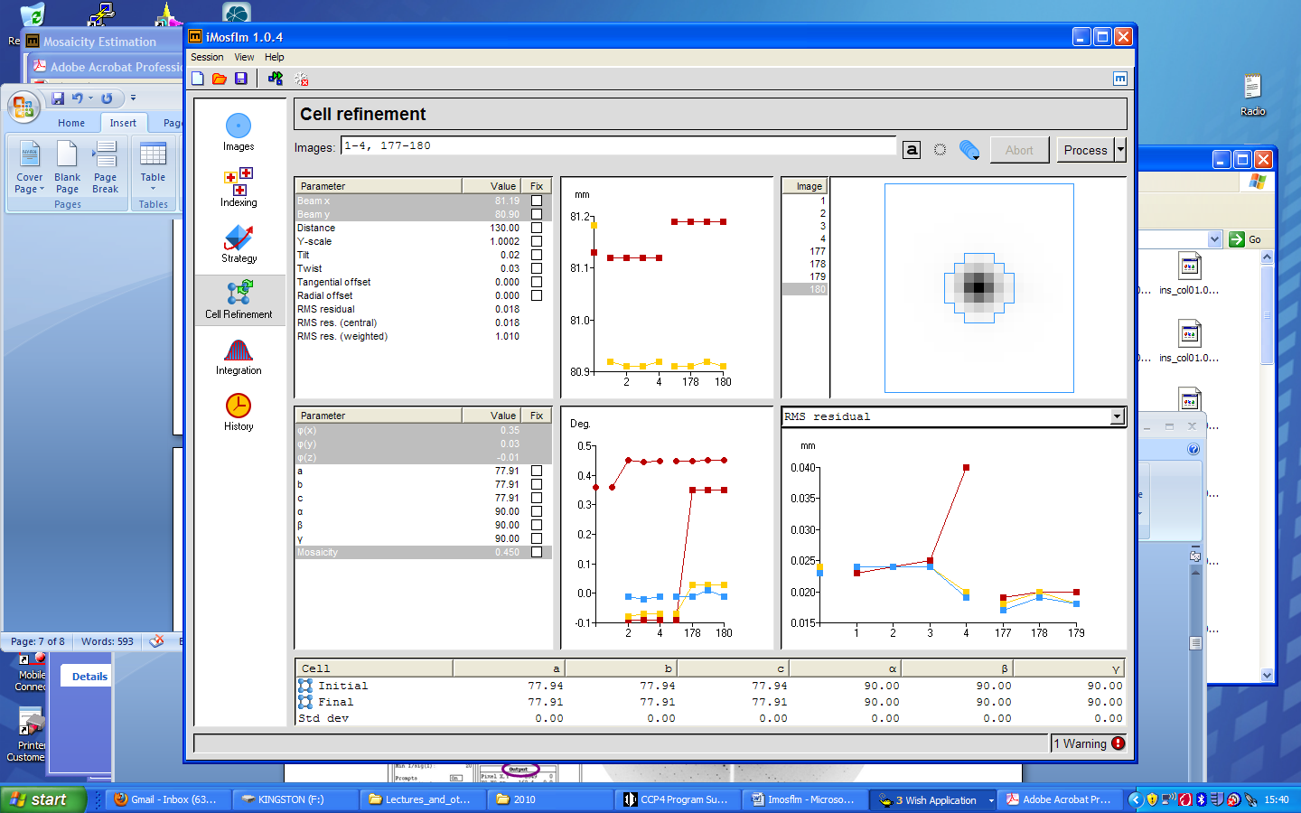









If all looks OK (no parameters wildly unstable), spot shape reasonable, then we can proceed to integrate the images. That is, extract intensity values and associate them with the right hkl index for each image. This will produce a reflection file in mtz format, the format used by CCP4. But be careful, it is not a ‘normal’ mtz file, it is a multirecord mtz file, that is with a record for each image, so many programs that normally read mtz files will not be able to read this one (hklview, for example). Choose an output file name that makes sense to you (please without spaces in the filename!) and which frames you want to process.

It can be wise (but slow) to follow the predictions on the images during processing. Again it is good to check that parameters change smoothly during refinement and to check the spot profiles (now they are also available for different parts of the detector and can be expanded by shift and mouse click, same again to get back to original view.

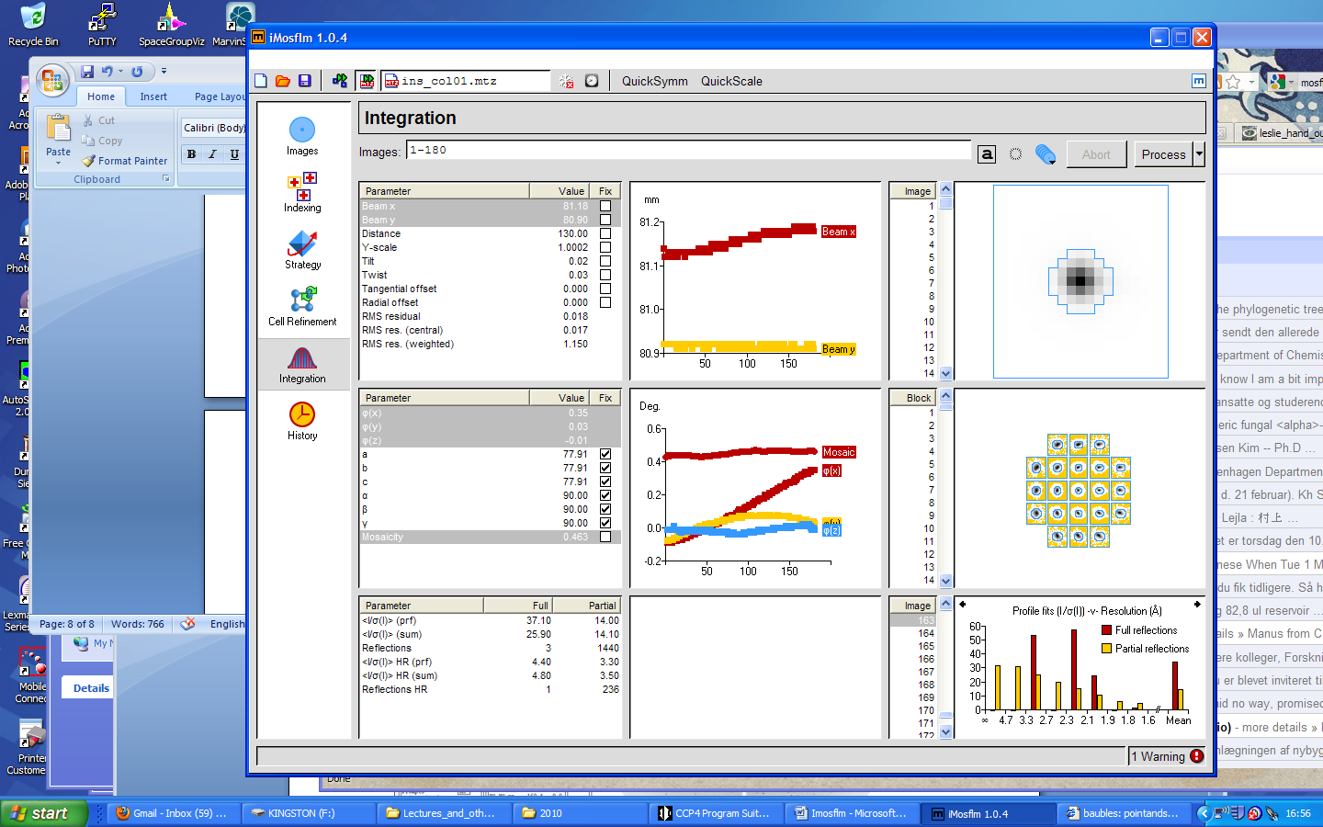







**Scaling (Scala)**

Now run SCALA from the CCP4 interface (from the **Data reduction** menu, **Scale and merge** intensities). Scala actually puts the images on the same scale, sums partially recorded reflections, and actually merges the symmetry equivalent reflections. Default parameters will be fine for this run, so just define the input file (MTZ in) and the output file (MTZ out) in the interface that comes up. At some point you might also want to change the resolution limits. Remember to tick the “Ensure data……add Rfree column” option as calculation of the Rfree is important for validation of the subsequent structure refinement.

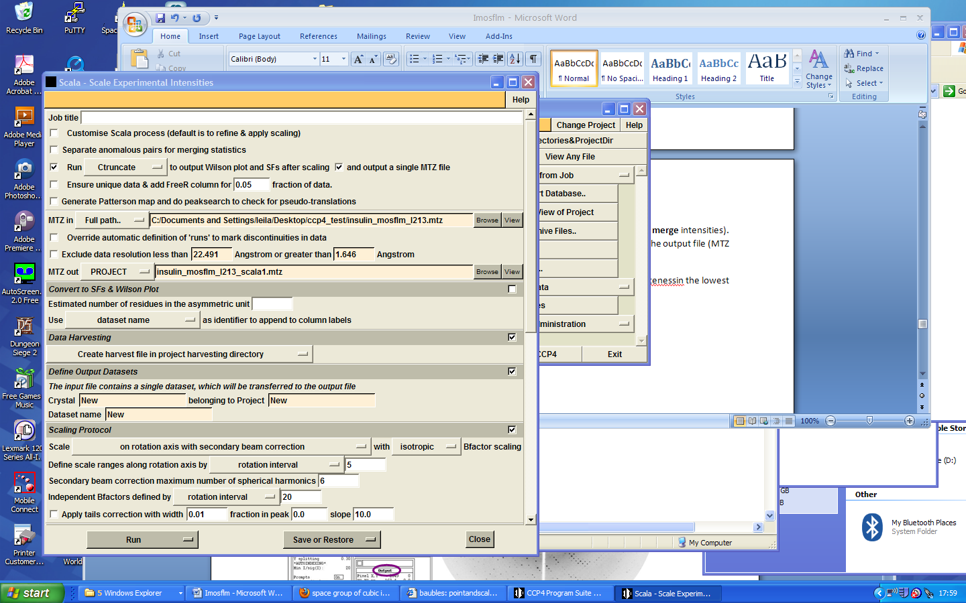









You can now look at the log file in different ways (make sure that you have the job you want to see log files for highlighted in the central window). When you open the log file (**View log file**) it is best to start by showing the summary and get an overview. Also there are various graphs extracted from the tables in the log file that can be viewed (**View Log Graphs**), some useful (there is even a twinning test), some less.

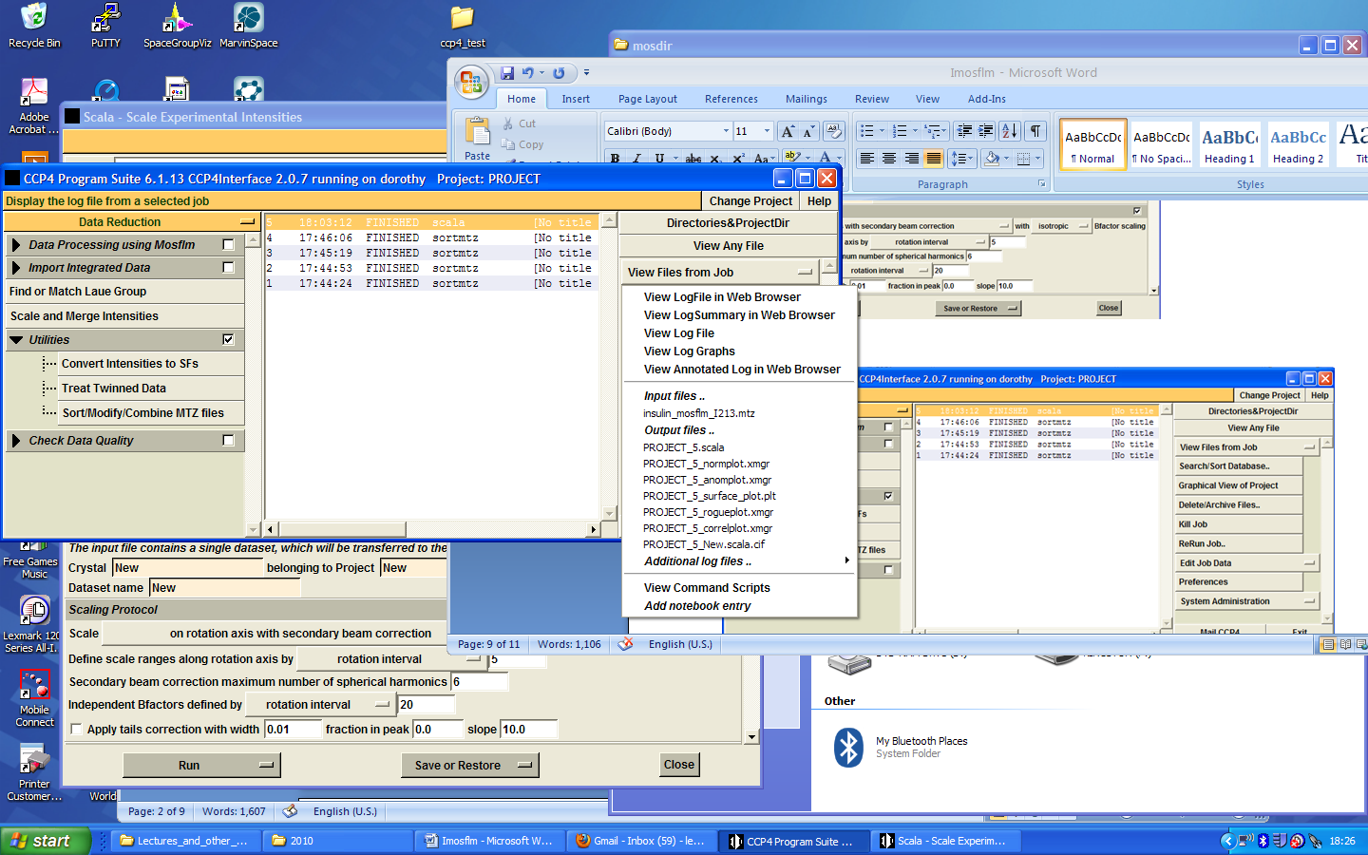





But sometimes it is useful to look at the full log file. Try and find the scaling factors between frames for example. If your data was giving you poor statistics how could this information help you work out what went wrong? How about completeness in the lowest resolution shell? What different types of Rmerge statistics (and their friends) can you find?

Check for systematic absences from log graphs. What is the right space group?

Once you have determined the right space group you can change it in the data-file header (if it should be changed) using “sort/modify/combine MTZ files” under “Data Reduction” and “Utilities”. The resulting MTZ file will be used for MOLREP and Refmac.