Molecular replacement and Refinement (By Pernille Harris)

Molecular replacement

In CCP4i chose Molecular replacement and then Molrep, one of many programs that can be used for Molecular replacement.

Fill in the title, (for instance gluA2).
MTZ in is you data file (col_1_001_scala1.mtz). Model in is your search model (template.pdb), and Coords out is the suggested solution from the program.
In Search Parameters you put the number of molecules in the asymmetric unit. Due to time limitations we will not do a prior cell content analysis, which could give an idea of the number of molecules in the unit cell/asymmetric unit. In this case you should search for one molecule (a single dimer) in the asymmetric unit.

Run the program. When it says FINISHED you may look in the log-file.

Interpretation of the output:
During Molecular replacement the 30 best orientations (rotations) of the molecule are found (Sol_RF). For each of these solutions the best 11 positions are found (translation, Sol_RF TF).

A large contrast between the best and the second best solution indicates that you have found a good solution. An example is shown below. For the rotation function, solution 1 with Rf/σ=10.76 is much better than solution 2 (Rf/σ=4.3).

Number of RF peaks : 30
theta phi chi alpha beta gamma Rf Rf/sigma
Sol_RF 1 27.14 113.17 178.77 112.48 54.26 66.14 0.1607E+06 10.76
Sol_RF 2 156.45 173.36 159.94 4.28 46.34 197.56 0.6421E+05 4.30
Sol_RF 3 161.82 -53.16 87.26 174.68 24.86 100.99 0.5563E+05 3.72
Sol_RF 4 150.85 -125.43 163.39 64.06 57.63 134.92 0.5368E+05 3.59
Sol_RF 5 71.30 -179.16 66.87 102.80 62.92 281.11 0.5083E+05 3.40
Sol_RF 6 27.93 -171.47 153.93 173.85 54.31 336.79 0.5016E+05 3.36
Sol_RF 7 26.82 79.11 170.66 73.88 53.44 95.66 0.4984E+05 3.34
Sol_RF 8 129.41 -137.55 105.41 92.64 75.85 187.75 0.4968E+05 3.33
Sol_RF 9 45.44 25.30 165.87 15.29 90.00 144.68 0.4939E+05 3.31
Sol_RF 10 47.31 -103.98 22.22 173.60 16.29 201.57 0.4907E+05 3.28

For each solution a translation function is found. The R-factor (Rfac) must be as small as possible and score as large as possible. In the example below Rfac=0.491 and score=0.574 for the best solution. Much better than Rfac=0.614 and score=0.295 for solution 2.

S_ RF TF theta phi chi tx ty tz TFcnt Rfac Scor
S___1__1 1 27.14 113.17 178.77 0.206 0.018 0.141 15.94 0.491 0.574
S___7__2 2 26.82 79.11 170.66 0.140 0.457 0.360 2.82 0.614 0.295
S___4__2 3 150.85 -125.43 163.39 0.434 0.426 0.125 2.68 0.615 0.293
S__10_15 4 47.31 -103.98 22.22 0.447 0.101 0.358 1.48 0.617 0.283
S___5__4 5 71.30 -179.16 66.87 0.340 0.245 0.398 2.08 0.618 0.270
S___3__1 6 161.82 -53.16 87.26 0.673 0.463 0.126 1.67 0.616 0.261
S___2_12 7 156.45 173.36 159.94 0.115 0.455 0.409 3.71 0.613 0.260
S___8__3 8 129.41 -137.55 105.41 0.070 0.894 0.398 2.11 0.618 0.257
S___6__5 9 27.93 -171.47 153.93 0.144 0.374 0.366 1.63 0.613 0.214
S___9__3 10 45.44 25.30 165.87 0.470 0.399 0.150 2.97 0.618 0.049

Refinement
The out coming structure must be refined
After the structure is solved, refinement is performed in the program refmac5, which is found in ccp4i in refinement. Follow the refinement in the log-file (or log-graph) written by following the R-factors. Especially, R_{free} is important. It must be as low as possible, and about 0.25 when the refinement is completely finished.

Initially, you make a so-called rigid body refinement, where you move the molecules as rigid bodies. MTZ in is your data file from Scala (or from “sort/modify/combine MTZ files” if you changed the space group after running Scala). PDB in is your solution from Molrep. PDB out is the resulting pdb-file from the refmac5.

You’ll run refmac5 several times. After rigid body refinement make restrained refinement. All geometric restrain parameters (under geometric parameters) must be used. Remember to read in a new pdb-file. The one that came out of refmac5 in your last run or the one you have made in the graphics program coot.

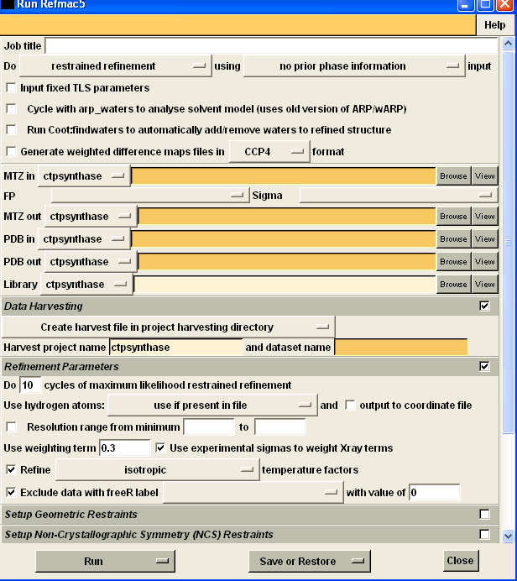

Visual investigation of the refinement progress
After running refmac5, you have to investigate the structure and build in the program coot.
In File-Open coordinates you read in the new pdb-file. In file-auto open mtz you read in the file ******_refmac1.mtz. This is a file containing your data (F_{obs}) and the calculated amplitudes (F_{calc}) and phases (ϕ_{calc}) coming from refmac5. Two electron density maps are generated. A 2F_{obs}-F_{calc}-map, with electron density, where atoms should be, and an F_{obs}-F_{calc}-map (a difference map), with positive (green) electron density, where atoms are lacking and with negative (red) electron density where atoms should be removed.

In coot you change, move, remove and add amino acid residues and a lot of other stuff. In draw-go to atom you can choose to look at a specific place in the structure. In calculate-model/fit/refinement-mutate and auto fit you may change specific amino acid residues.

Get help from the tutorial or ask if you get stuck.
If you apparently lose your corrections to the model fetch one of us – it is possible to get it back.

When you have changed the structure and want to run refmac5 once more, remember to save your new pdb-file.

Validate and describe the structure.
Part of the structure validation is to make sure that R_{free} does not increase. Furthermore, you should check the Ramachandran plot, which gives information on the geometry of the main chain. This can be done on the way in coot.

